

**UNIVERSIDAD TECNOLÓGICA DE**

**SAN LUIS RIO COLORADO**

**Secure Software Development Lifecycle**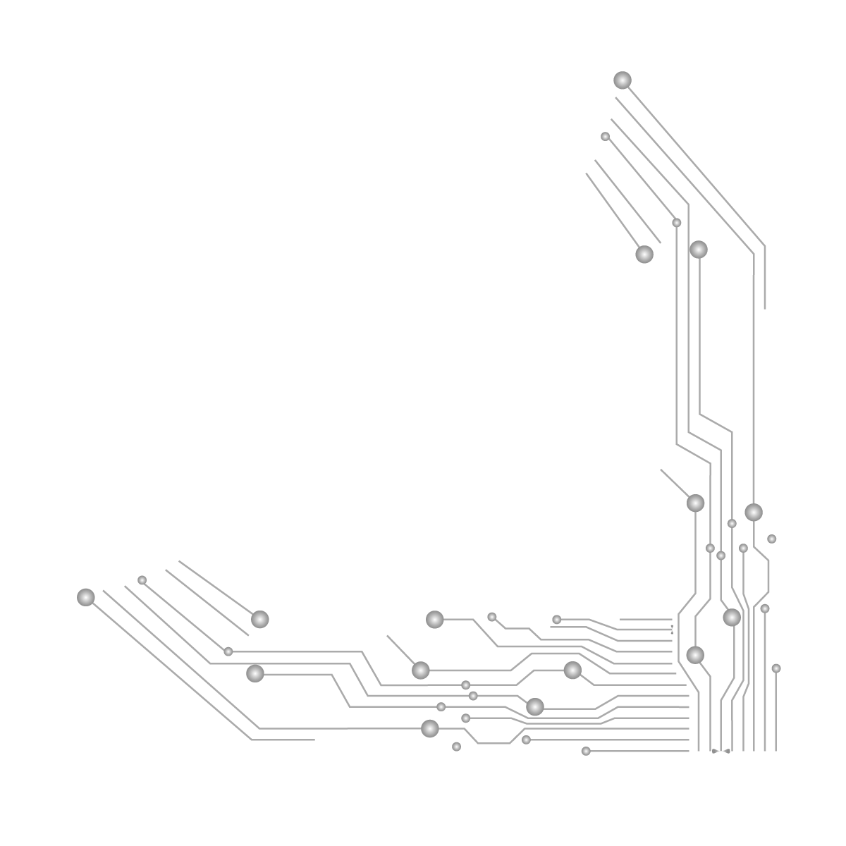

**MTRO. Aurelio Flores**

**ALUMNO: VICTOR MANUEL GALVAN COVARRUBIAS**

**ING. EN DESARROLLO Y GESTIÓN DE SOFTWARE**

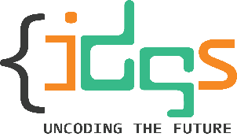San Luis Rio Colorado, Sonora Mayo, 2022

**Secure Software Development Lifecycle** is the process of including security artifacts in the Software Development Lifecycle. Consists of a detailed plan that defines the process organizations use to build an application from inception.

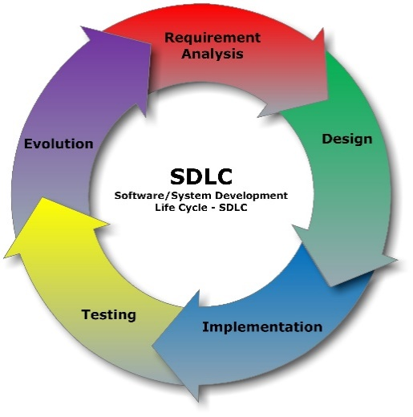Development teams use different models. However, all models usually follow these phases:

* Plan and requirements
* Design
* Test plan
* Coding
* Testing
* Release
* Maintenance

There are seven phases in most SDLCs,  
although they may vary according to the methodology used, such as Agile or Waterfall:

* Concept
* Planning
* Design and Development
* Testing
* Release
* Sustain
* Disposal

Each security activity should correspond with a phase in the SDLC

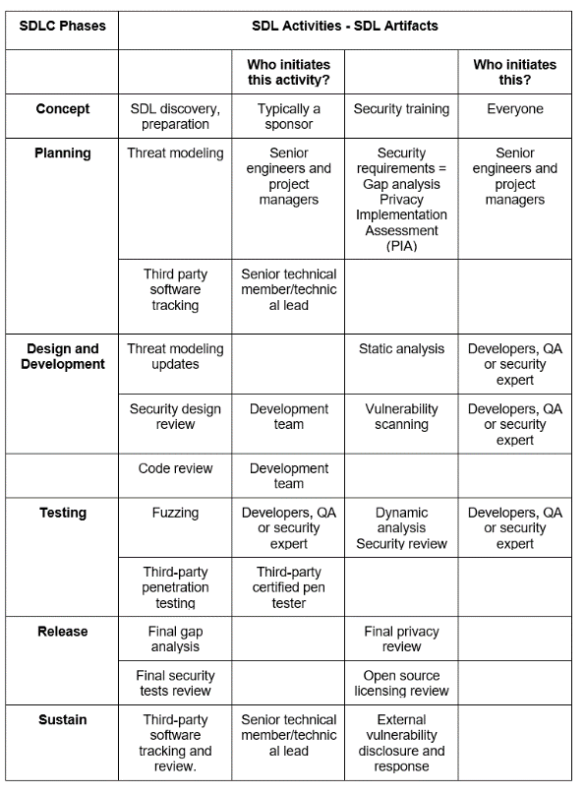

**Security testing** checks how vulnerable is the new product to attacks. The activities include:

* **Static Analysis**: identifies the exact location of weaknesses by analyzing the software without executing it.
* **Dynamic Analysis**: identifies weaknesses by running the software, helping find infrastructure flaws and patch errors.
* **Vulnerability Scanning**: injects malicious inputs against running software to check how the program reacts.
* **Fuzzing**: involves giving invalid, random data to a program, to check for access protocols and file formats
* **Third-party penetration testing**: the tester simulates an attack to discover coding or system configuration flaws, and discover vulnerabilities a real attacker can exploit. It is required that the tester is an external party not connected to the team.

**Phases of Secure Software Development Life Cycle**

* **Requirements**

In this early phase, requirements for new features are collected from various stakeholders. It’s important to identify any security considerations for functional requirements being gathered for the new release.

* **Design**

This phase translates in-scope requirements into a plan of what this should look like in the actual application. Here, functional requirements typically describe what should happen, while security requirements usually focus on what shouldn’t.

* **Development**

There are usually established secure coding guidelines as well as code reviews that double-check that these guidelines have been followed correctly. These code reviews can be either manual or automated using technologies such as static application security testing.

* **Verification**

Applications go through a thorough testing cycle to ensure they meet the original design & requirements. This is also a great place to introduce automated security testing using a variety of technologies.

* **Maintenance and evolution**

Vulnerabilities that slipped through the cracks may be found in the application long after it’s been released. These vulnerabilities may be in the code developers wrote, but are increasingly found in the underlying open-source components that comprise an application.